**ENG 111**

**Week 2 Discussion**: Introduction to Corporate Finance

*Example 1:*

|  |  |  |  |
| --- | --- | --- | --- |
| Inventory | 3,000 | Revenue | 13,000 |
| Fixed Assets | 12,000 | Cost | 7,000 |
| Cash | 8,000 | Depreciation | 1,500 |
| Acct. Pay. | 4,500 | Interest | 1,400 |
| Long-term Debt | 14,000 | Tax (%) | 35% |
| Acct. Rec. | 8,500 | Retention Ratio (%) | 80% |
| Common Stock | 5,000 | Ret. Earnings 2015 | 3,388 |

Accounts are given in 2016, except for Retained Earnings. Find the Short-Term Debt and Retained Earnings for 2016.

**INCOME STATEMENT**

|  |  |
| --- | --- |
| Revenue | 13,000 |
| Cost | (7,000) |
| Gross Profit | 6,000 |
| Depreciation | (1,500) |
| EBIT | 4,500 |
| Interest | 1,400 |
| Pre-Tax Income | 3,100 |
| Tax (35%) | 1,085 |
| Net Income | 2,015 |
| Add to Ret. Earnings (80%) | 1,612 |
| Dividends (20%) | 403 |

**BALANCE SHEET**

|  |  |
| --- | --- |
| Assets: |  |
| Current Assets |  |
| … Cash | 8,000 |
| .. Accounts Receivables | 8,500 |
| . Inventory | 3,000 |
| Total Current Assets | 19,500 |
| Fixed Assets | 12,000 |
| Total Assets | 31,500 |
|  |  |
| Liabilities: |  |
| Current Liabilities |  |
| .. Accounts Payable | 4,500 |
| .. Short Term Debt (Notes Payable) | *3,000* |
| Total Current Liabilities | 7,500 |
| Long Term Debt | 14,000 |
| Total Liabilities | 21,500 |
| Equity: |  |
| Retained Earnings | *3,388+1,612 = 5,000* |
| Common Stock | 5,000 |
| Total Liab&Equity | 31,500 |

**2.** The accounts related to the Balance Sheets as well as Income Statements for Company Y are given below (as of Dec 31st 2015 and Dec 31st 2016). Company Y does not distribute any dividends and had no depreciation in 2015 and 2016.

|  |  |  |
| --- | --- | --- |
| Accounts in $ | 2015 | 2016 |
| Sales | 1,000 | 1,250 |
| Common Stock | 888 | 888 |
| Cost of Goods Sold | 700 | 875 |
| Accumulated Retained Earnings | 112 | 362 |
| Interest | 160 | 62.5 |
| Long Term Debt | 1600 | 625 |
| Taxes | 28 | 62.5 |
| Notes Payable | 100 | 1,500 |
| Net Fixed Assets | 1,800 | 2,250 |
| Accounts Payable | 300 | 375 |
| Inventory | 600 | 750 |
| Accounts Receivable | 440 | 550 |
| Cash | 160 | 200 |

|  |  |  |
| --- | --- | --- |
| *Company Y Inc., Pro Forma Income Statement* | | |
|  | ***2015*** | ***2016*** |
| *Sales* | *$1,000* | *1,250* |
| *Costs (COGS&Adm&Dep)* | *700* | *875* |
| *Interest* | *160* | *62.5* |
| *Taxable Income* | *$140* | *312.5* |
| *Taxes(20%)* | *28* | *62.5* |
| *Net Income* | *$112* | *250* |
| *Dividends* | *0* | *0* |
| *Additions to Retained Earnings* | *$112* | *250* |

a) Produce Company Y’s Income Statements and Balance Sheets for 2015 and 2016.

|  |  |  |  |  |  |
| --- | --- | --- | --- | --- | --- |
| ***Company Y Inc., Pro Forma Balance Sheet*** | | | | | |
|  | ***2015*** | ***2016*** |  | ***2015*** | ***2016*** |
| *Current Assets* |  |  | *Current Liabilities* |  |  |
| *Cash* | *160* | *200* | *Accounts Payable* | *300* | *375* |
| *Accounts Receivable* | *440* | *550* | *Notes Payable* | *100* | *1500* |
| *Inventory* | *600* | *750* | ***Total Current Liabilities*** | *400* | *1875* |
| ***Total Current Assets*** | *1200* | *1500* | *Long-Term Debt* | *1600* | *625* |
| *Net Fixed Assets* | *1800* | *2250* | *Owners’ Equity* |  |  |
|  |  |  | *Stock* | *888* | *888* |
|  |  |  | *Acc. Retained Earnings* | *112* | *362* |
|  |  |  |  |  |  |
| ***Total Assets*** | *3000* | *3750* | ***Total Liabilities and O.E.*** | *3000* | *3750* |

b) Calculate the Cash Flow from Assets for 2016:

*Operating Cash Flow = 1250-875- 62.5 = 312.5*

*Cash Flow to NWC = (1500 - 1875 ) – (1200- 400) = -375-800 = - 1,175*

*Cash Flow to Fixed Assets = 2,250-1,800 = 450*

*Cash Flow From Assets = 312.5 – (-1,175) – 450 = 1,037.5*

c) Calculate the Cash to Creditors and Stock Holders for 2016:

*Cash to Creditors = 62.5 - (625-1,600) = 1,037.5*

*Cash to Stock Holders = 0*

d) Does it take more or less time for Company Y to sell its inventory in 2016 compared to 2015?

*Days’ Sales in Inventory for 2015: 365 / (700/600) = 312.86*

*Days’ Sales in Inventory for 2016: 365 / (875/750) = 312.86*

e) Did the Debt/Equity ratio go up or down from 2015 to 2016?

*Debt / Equity for 2015 = 2,000/1,000 = 2*

*Debt / Equity for 2016 = (1,875+625) /(888+362) = 2 … stays the same*

f) How did the Net Working Capital change from 2015 to 2016? Would you interpret this change as a positive or negative move with respect to the financial health of the company?

*NWC 2015 = 1,200-400 = 800, NWC 2016 = 1,500 – 1,875 = -375*

*It looks bad since the company cannot cover its short term liabilities with its liquid assets. Also note that the Operating cash flow is not enough to cover the difference between Short Term Liabilities and Assets, which is alarming!*

**3.** Balance Sheet and Income Statement of Zwitter Inc. are given below as of Dec 31 2014 and Dec 31 2015.

Calculate 2015 Cash Flow to/from:

1. (4 points) Assets
2. (4 points) Creditors
3. (4 points) Stock Holders
4. (4 points) If Zwitter distributes same percentage of its Net Income as dividends each year, what was the amount of dividends that were distributed in 2014?
5. (4 points) Which accounts would be affected (and by which amount) in the Balance Sheet if Zwitter were to distribute NO dividends in 2015 but retain all earnings (Net Income) within the company?

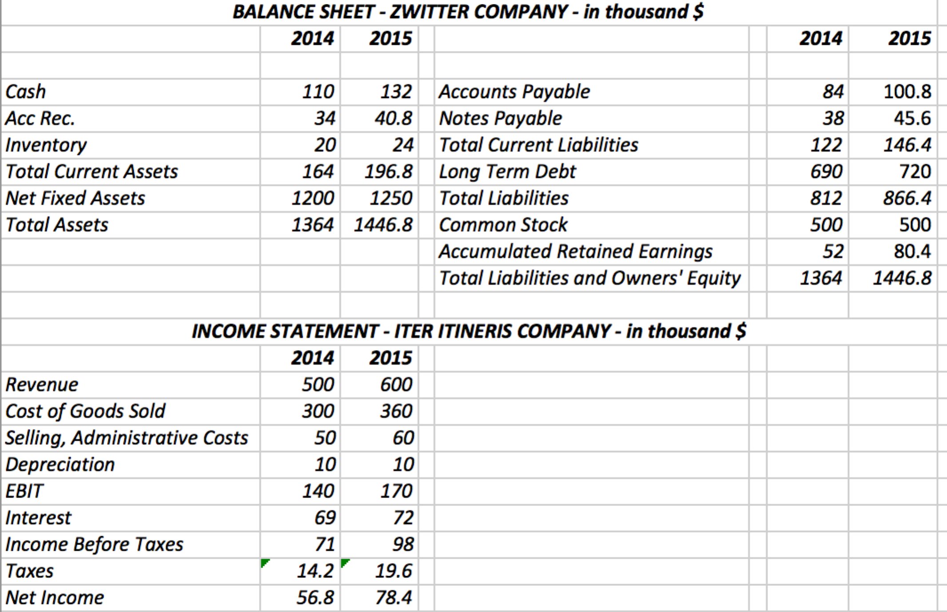

***INCOME STATEMENT ZWITTER – in thousands***



*Cash Flow from Assets:*

*Operating Cash Flow = EBIT + Depreciation – Taxes = 170+10-19.6 = 160.4*

*Cash to Net Working Capital = (Ending NWC – Beginning NWC) = (196.8-146.4) – (164-122) = 8.4*

*Cash to Fixed Assets = (Ending Net Fixed Assets – Beginning Net Fixed Assets + Depreciation) = 1250-1200+10 = 60*

*Cash Flow from Assets:*

*160.4-8.4-60 = 92*

*Cash Flow to Creditors:*

*Interest - (Ending Long Term Debt – Beginning Long Term Debt) = 72 - (720-690) = 42*

*Cash Flow to Stock Holders:*

*Dividends - (Ending Stock – Beginning Stock) = 50 – (500-500) = 50*

*Note that Dividends are not given directly. However, one can find the dividends for 2015 by looking at the difference in accumulated retained earnings change from 2014 to 2015:*

*80.4 – 52 = 28.4 must be the amount that is retained from 78.4 of Net Income. Then 78.4-28.4 = 50 must be distributed as dividends in 2015.*

*If Zwitter distributes the same percentage of its Net Income as dividends each year, it distributes 50/78.4 = 63.78%*

*Therefore, in 2014 Zwitter must have distributed 56.8 * 63.78% = 36.22 as dividends.*

*If Zwitter were to distribute no dividends in 2015, Accumulated Retained Earnings would have been higher by 50. Then, this money would have been used in the company in some way. If company decides to keep it in its cash account until it has a use for it, Cash Account would have been higher by 50. If it decides to buy fixed assets, Fixed Assets would increase by 50 or pay off debt, Long Term Debt would go down by 50. Or a combination of these activities would be possible with the extra cash.*